All School Picnic
June 5, 2024
Bloomer State Park—Stone Shelter
Rochester Hills, Michigan

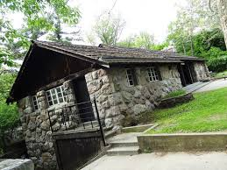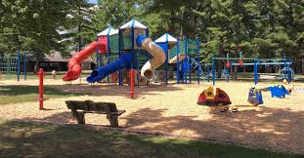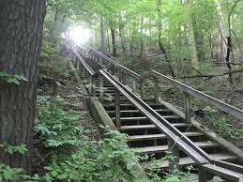

This year’s School Picnic will be on Wednesday, June 5th, at Bloomer Park in Rochester Hills. Students and their families are invited to attend for a day of fun, fellowship, and food.
We have rented the Bloomer Stone Shelter for the day. The shelter lends itself well for our size group and having lunch. The cost will be $5.00 per person to help cover the cost of the shelter rental, and the food (hot dog, chips, cookie, and water). We suggest you bring an additional beverage. You may bring additional food if you like...No alcoholic beverages permitted.
• Your child should arrive at the park by 9:30 a.m. and planned activities will be done by 2:30 p.m. Families can certainly stay at the park longer if they wish.
• If you are picking up your child directly from the park, please be at the park by 2:30 p.m.
• If you cannot come to the picnic and your child wishes to attend, a carpool to and from the park must be arranged as well as ensuring that another adult attendee, not your child’s teacher, will be responsible for supervising your child throughout the picnic time. The name of this responsible adult picnic attendee must be communicated to your child’s teacher, Mrs. Mackinder, the preschool director, or Mr. Francik, the school principal.
• There will be no latchkey in the morning or afternoon on this day.
• Maps will be available.
• Please fill out the form at the bottom of the page and return it no later than Friday, May 31.

I give my child, ___________________________, permission to attend the school picnic at Bloomer Park on Wednesday, June 5th.
This signed agreement absolves the teacher, St. Paul Lutheran School, and any and all members of its governing boards of any responsibility for the safety, welfare, health and wellbeing of the child or children named above, beyond such matters as may be called reasonable care for children in the custody of a teacher and subject to the teacher’s clear instructions, and assumes personally and exclusively all responsibility and liability for accident, injury, etc. which may occur on the above-named child/children during the time of the specified activity as set forth at the beginning of the paragraph.
______________________________________
(Parent’s Signature)
_______# of students attending at $5.00 each _______# of adults attending at $5.00 each Amount enclosed: _____________
_____Yes, I can drive _____Sorry, I can’t drive I can take my child and ________more students.
Emergency Phone Number: _______________________________________________

