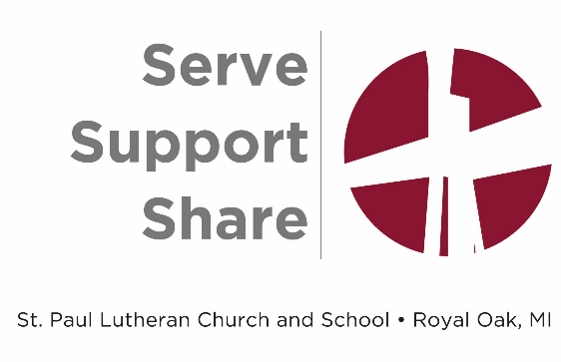
Pastor Vacancy Update
Now that we have celebrated Pastor Andrzejewski’s ministry at St. Paul, the entire St. Paul congregation enters a time of transition. During this time, there are many steps in the process to find and call a new pastor occurring.
What is a call??
You may be asking yourself this. Whether you are a Lutheran or not, you may not have had a lot of experience with the call process in the Lutheran Church. Here is a little information about this faith-filled process.
The "Divine Call" is a spiritual appointment directed by God through the Holy Spirit as opposed to a secular job hire. The Lutheran Church- Missouri Synod (LCMS) uses a call process to determine where its workers will serve the church. In our congregation, we have a pastor, a principal and many teachers who are "called" to serve at St. Paul.
So, what is this process for our pastoral vacancy? Church members, under the guidance of the Holy Spirit, will begin a time of self-examination using a Pastoral Profile survey. This survey will be emailed to all members asking them a bit of biographical information about themselves and then asking for input into the strengths and weaknesses of the congregation as well as qualities we are seeking in our next pastor. The results of these surveys will be shared with the congregation and forwarded to officials in the LCMS to be input into the national database of Lutheran pastors. Any pastor matching the needs identified by us will be flagged and reviewed, and a list of potentially 5-15 candidates will be forwarded to our congregation. This process takes at least 6-8 weeks.
In the meantime, the congregational Vestry will appoint a Call Committee which prayerfully commits to studying the candidates and, eventually, to interviewing candidates. At this time, we will also be accepting nominations of pastors that are known to our members who would be open to a call.
All the above-described prayerful Spirit-led preparation culminates in the special Voter's Meeting. At that meeting, the congregation will vote to extend a formal "Divine Call" to a chosen candidate. That pastor will then consider whether the Holy Spirit is moving him from his current "Divine Call" to the new "Divine Call" issued by St. Paul, and he will decide typically within 3-5 weeks. If the call is accepted, arrangements are made for his transition to St. Paul. If the call is declined, another Voter's Meeting is scheduled to choose another candidate.
Typically, this process can take 6 months to a year or longer. It is not a quick process, nor should it be, considering all the prayers and attention to detail that are needed. During this season, let Paul's words to the church at Philippi guide you: "Do not be anxious about anything, but in everything, by prayer and petition, with thanksgiving, present your requests to God. And the peace of God, which transcends all understanding, will guard your hearts and your minds in Christ Jesus. (Philippians 4:6-7). The school administration is committed to keeping school families informed at every stage of this process and asking for your continued prayers and support.

Call Committee Members
Chip Eising – Committee Chairperson
Chris Schultz
Chris Francik
Greg Paul
Blyth Mackinder
Leanne Millinger
Erik Olsen
Rick Gordon
Jeff Szerdi

Throughout this pastoral call process, please don’t hesitate to contact Chris Francik, Greg Paul, Blyth Mackinder, or Jeff Szerdi. They are school staff members or school parents and are happy to answer any questions you may have about this process.

