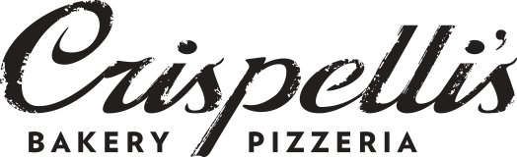
A Tasty Way to “Raise Some Dough”
Crispelli’s of Berkley will donate 20% of your check,
excluding tax and tip, to benefit:
St. Paul Lutheran School
On the following date:
Monday February 9th, 2026
11AM-9PM
DINE IN OR CARRYOUT
Or join us, your St. Paul family, at the restaurant at 6:00pm for a dine in dinner and fellowship experience (We are raffling a Movie Basket see below).
Valid only at:


Crispelli’s of Berkley
28939 Woodward Ave,
Berkley, MI 48072
248-591-3300

**Please present this certificate at the time of payment to have 20% of your check’s value, excluding tax and tip, donated to the organization above. **
Not to be used with any other coupons or discounts.
Valid for only the date and location above.
** APPLIES ONLY TO THOSE AFFILIATED WITH THE ABOVE ORGANIZATION **
https://www.crispellis.com

